**Ideation Phase**

**Define the Problem Statements**

|  |  |
| --- | --- |
| Date | 31 January 2025 |
| Team ID | LTVIP2025TMID34308 |
| Project Name | **Grain Palette –A Deep Learning Odyssey in Rice Type Classification Through Transfer Learning** |
| Maximum Marks | 2 Marks |

**Customer Problem Statement Template:**

Create a problem statement to understand your customer's point of view. The Customer Problem Statement template helps you focus on what matters to create experiences people will love.

A well-articulated customer problem statement allows you and your team to find the ideal solution for the challenges your customers face. Throughout the process, you’ll also be able to empathize with your customers, which helps you better understand how they perceive your product or service.

Reference: https://miro.com/app/board/uXjVJcCGjB0=/?share_link_id=779636956266

**Example:**

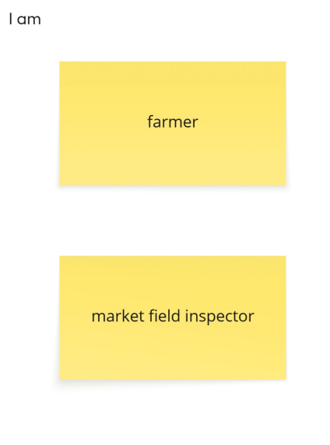 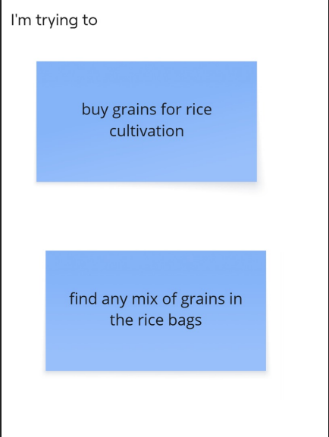 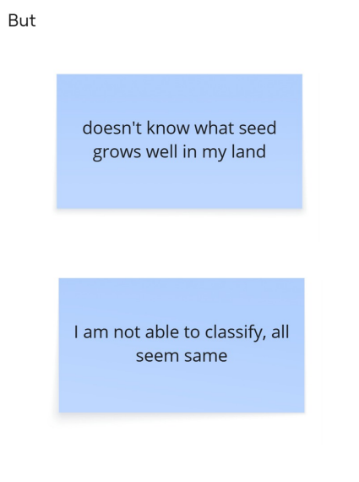 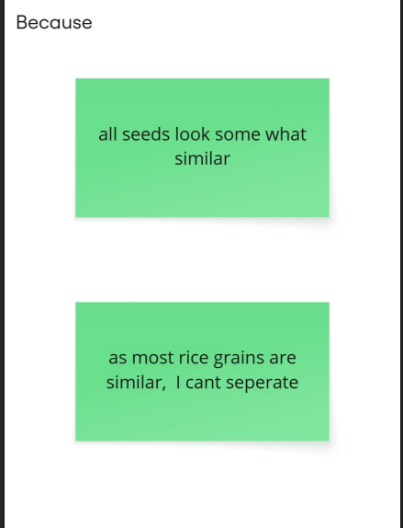 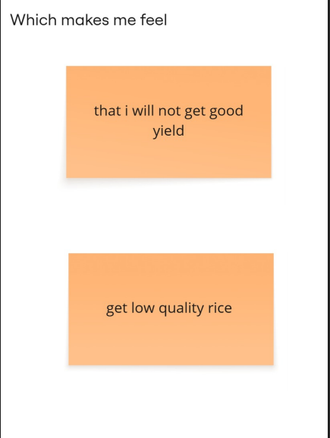

|  |  |  |  |  |  |
| --- | --- | --- | --- | --- | --- |
| **Problem Statement (PS)** | **I am (Customer)** | **I’m trying to** | **But** | **Because** | **Which makes me feel** |
| PS-1 | farmer | Buy grains for rice cultivation | Don’t know what seed is suitable for my land | All seeds look similar | That I will get less yield |
| PS-2 | Market field inspector | Find any mix of grains in the rice bags | I am not able to classify, all seem same | As most rice grains are similar, I can’t separate | Get low quality rice grains |